Manor Park School
Behaviour Policy
Updated January 2021

The Education Act places on all schools (and staff within the school) the duty to state and pursue policies designed to promote good behaviour and discipline.

At Manor Park School Good Behaviour is promoted and recognised.
We teach the children that it is their responsibility to make the most of their time at school.
We emphasise the need to challenge yourself, do your best and tackle new learning with enthusiasm.
Children are expected to behave in a way that allows all children to learn.
Pupils are expected to show respect to all adults and children at school and at home.

Manor Park seeks to put into practice the shared values of the school community which consists of students, school staff, Governors and the wider community.
RECOGNITION OF POSITIVE BEHAVIOUR AND ATTITUDE
The school focuses on positive praise, catching children doing something good.
Praise can be linked to work, effort, willingness, contribution, co-operation, teamwork, thoughtful actions towards and for others and personal achievement.

Types of recognition include:
- Positive, verbal, comments in class and/or reinforcement at end of lesson.
- Consistent use of the ClassDojo – a Dojo point is given to children in the morning, lunchtime and afternoon for following the school’s rules of ‘Ready, Respectful, Safe’.
- Extra Dojo points are given when adults identify positive behaviour including:
- Furthering their learning through independent work and homework
- Considering other pupils before themselves
- Setting a good example to others
- Celebrating the success of others

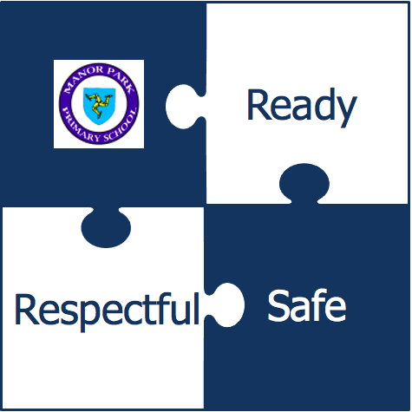

- Every week a child is chosen from each class to be the ‘Class Star’. They are presented with a certificate and their positive behaviour is explained to the rest of the school during the weekly Praising Assembly.

Focusing on positive behaviour and teacher’s giving their time and attention to those pupils who are working hard and trying their best during learning time, ensures that pupils with a positive learning attitude are recognised and encouraged.

SANCTIONS
The school has agreed standards of behaviour because it believes that good and thoughtful behaviour is essential for effective learning. If pupils choose not to conform to these agreed standards a system of stepped sanctions is used consistently across the school.
When managing negative behaviour all staff are
- Calm
- Patient
- Positive
- Fair
- Consistent
As a staff we agree that we do not:
- Shout or scream at pupils
- Use negative comments – especially about the person
- Punish a whole group on a regular basis
- Fail to follow through with agreed sanctions
- Use put downs and sarcasm
- Ridicule or humiliate children
- Cause intentional embarrassment
- Make it personal ~ We like the person, we may not like their behaviour.

STEPPED SANCTIONS WE USE
- Non verbal reminder (eye contact from adult, making disapproval clear).
- Verbal reminder
- Moved within the classroom - followed by discussion with teacher in pupils own time, using restorative questions.
- Moved to another classroom/chairs outside for quiet time - followed by discussion with teacher in pupils own time, using restorative questions. Pupils take an egg timer for a limited amount of time.
- Involvement with a member of the Senior Leadership Team.
- Parents invited in to discuss behaviour

IMPOSITIONS
When a pupil chooses not to engage with their learning this usually results in work not being completed. Pupils from Year 2 upward will be required to make up the lost learning time by completing their work at home that evening. A short note will be attached to the task to be completed with an explanation of the required work (what/how much/when it needs to be back in school). If it is not completed at home then it will be finished at break time or lunchtime in school the following day.
REPEATED NEGATIVE BEHAVIOUR
Pupils who persistently repeat the same negative behaviours will complete specific work with the Child and Family Support Worker to address these issues. This may be a one off meeting or a series of sessions following a meeting with parents.

The Deputy Headteacher may also meet with pupils to explore more serious repeated negative behaviours with the aim of reducing/stopping them. These meetings will take place outside learning time. Where required, self-regulation plans will be formulated with pupils to help them manage themselves more positively so they are able to reflect the school’s three rules.

Extreme Behaviour
Extreme negative behaviour is not acceptable at Manor Park School from pupils, staff or parents. Parents who display behaviour that is openly aggressive or threatening may be asked to leave the premises. It is expected that teachers are approached and spoken to with respect by pupils and their families. Parents who have issue with a teacher should follow the DESC complaints procedure.

Informal Suspension
If a child is unwilling to co-operate with teaching staff and their behaviour is so disruptive as to prevent other pupils learning, parents will be asked to take them home for the remainder of the session/day. This includes swearing at or making disparaging remarks to members of staff.
Similarly, if a child purposefully hurts another child they may be sent home to reflect on their actions as clearly this is not acceptable behaviour.

Formal Suspension
In very rare cases it may be necessary to formally suspend a pupil, e.g. if there has been a serious physical attack on another person. In this event the school will follow the procedures laid down by the Department of Education and Children and the Isle of Man Children’s Act 2001.

Physical Restraint
Appropriate occasions for physical restraint might include separating children who are fighting, calming down a young child and preventing a child from injuring themselves or others, or from damaging property. All staff will follow the DESC Policy on Physical Contact, Control or Force on Pupils, and use Team Teach Positive Handling techniques. Staff are trained to Positively Handle children.

Monitoring
Monitoring is carried out in formal and informal ways by staff:
- Record of sspensions / exclusions
- Referral to outside agencies- Incident sheets/logs
- Individual Behaviour Plans, Self-Regulation Plans and Risk Assessments
- Annual Reports
- Personal Education Plans
- Interviews/phone calls/letters to parents
- Attendance and lates
- Medical information
- Direct observation of student behaviour in/out of lessons
- Lunchtime ban records

It is our collective responsibility to promote good behaviour that will help to ensure a consistent approach across the school and move us towards being an institution where all pupils and staff know what is expected of them.

Our Behaviour Policy has been informed by current school behaviour Research by Pivotal and consultant Paul Dix.

Linked Policies:
Dealing With Unacceptable Behaviour by Parents and Visitors on School Premises
DESC Complaints Procedure
DESC Policy on Physical Contact, Control or Force on Pupils
Suspension of Pupils:Policy and Procedures (July 2019)

MPS 01/2021

