Manor Park Primary School

Anti-Bullying Policy
Approved By: | Full Governing Body
Date: | February 2020
Review Date: | February 2022
Signed:

Statement of Intent
We are committed to providing a caring, friendly and safe environment for all of our pupils so they can learn in a relaxed and secure atmosphere. Bullying of any kind is
unacceptable at our school. If bullying does occur, all pupils should be able to tell and know that incidents will be dealt with promptly and effectively.
We are a TELLING school. This means that anyone who knows that bullying is happening is expected to tell the staff.

Manor Park Anti-Bullying Code
Treat everyone with respect.
Bullying breaks this rule, because if you hurt threaten or frighten someone you are not treating them with respect.
You should always treat others, as you would like to be treated.

Definition of Bullying
“Bullying is deliberately hurtful behaviour with the intention of harm repeated over a period of time”.
Bullying is not:
- A one-off incident of name calling, arguing or fighting
- A friend sometimes being nasty
- Falling out with people
- Short arguments
- Friends breaking up
- Occasional teasing
- Bossing others around
- Boisterous behaviour
Bullying may include:
name-calling; taunting; mocking; making offensive comments; kicking; hitting; pushing; taking belongings; inappropriate text messaging and emailing; sending offensive or degrading images by phone or via the internet; producing offensive graffiti; gossiping; excluding people from groups; spreading hurtful and untruthful rumours. Although sometimes occurring between two individuals in isolation, it quite often takes place in the presence of others.
Pupils are bullied for a variety of reasons. Specific types of bullying include:
- bullying related to race, religion or culture
- bullying related to SEN or disabilities
- bullying related to appearance or health conditions
- bullying of young carers, looked-after children or otherwise related to home circumstances

Objectives of this Policy
- All governors, teaching and non-teaching staff, pupils and parents should have an understanding of what bullying is.
- All governors and teaching and non-teaching staff should know what the school policy is on bullying, and follow it when bullying is reported.
- All pupils and parents should know what the school policy is on bullying, and what they should do if bullying arises.

Signs and Symptoms
A child may indicate by signs or behaviour that he or she is being bullied. Adults should be aware of these possible signs and that they should investigate if a child:
- is frightened of walking to or from school
- doesn't want to go on the school / public bus
- begs to be driven to school
- changes their usual routine
- is unwilling to go to school (school phobic)
- begins to truant
- becomes withdrawn anxious, or lacking in confidence
- starts stammering
- attempts or threatens suicide or runs away
- cries themselves to sleep at night or has nightmares
- feels ill in the morning
- begins to do poorly in school work
- comes home with clothes torn or books damaged
- has possessions which are damaged or " go missing"
- asks for money or starts stealing money (to pay bully)
- has dinner or other monies continually "lost"
- has unexplained cuts or bruises
- comes home starving (money / lunch has been stolen)
- becomes aggressive, disruptive or unreasonable
- is bullying other children or siblings
- stops eating
- is frightened to say what's wrong
- gives improbable excuses for any of the above
- is afraid to use the internet or mobile phone
- is nervous & jumpy when a text or cyber message is received
These signs and behaviours could indicate other problems, but bullying should be considered a possibility and should be investigated.

Prevention of Bullying
At Manor Park school we seek to identify early signs of bullying in the classroom and in the playground and we work to prevent it developing further by:-
- Giving time to listen to children’s concerns at playtimes, lunchtimes and at other times of the day.
- Valuing each child’s comments and trying to ensure that they are appropriately dealt with.
- Being aware of any repeated reports of incidences involving the same child or groups of children.
- Ensuring that all children are aware of acceptable standards of behaviour and the positive attitudes we expect.
- Pupils are taught that children who act as bystanders need to understand their responsibilities in acting to ensure that bullying is dealt with effectively
- Raising the awareness of bullying through inclusion in PSHE Jigsaw sessions, circle time, assemblies and in Anti-Bullying Week each year.
- Teachers using a range of methods to help prevent bullying and to establish a climate of trust and respect for all. They may use drama, role play, stories etc within the curriculum.
- Inviting pupils to tell us their views about a range of school issues, including bullying, in pupil interviews questionnaires and through the School Council.

Monitoring the Policy
- The effectiveness of the policy should be monitored by all staff and, in particular the School Leadership Team.
- A record should be kept of any reported incidents and wherever practicable, information shared with all concerned parties (parents, teachers, support staff, lunchtime ancillaries etc.)
- Reported incidents are recorded on Arbor. Communication notes and text messages are kept on Arbor and are anonymised if printed and given to parents. (text messages are sent via Arbor)
- Where a pupil is suspended for bullying, the Chair of Governors must be informed.
- Pupil questionnaires and School Council Surveys should be used to inform the SLT of bullying concerns of the pupils.

Evaluation of the Policy
The effectiveness of the school’s policy and provision will be determined by the levels of satisfaction as indicated on the pupils’ questionnaire, the parent’s questionnaire and monitoring of incidents by the SLT.

Procedure for Investigating Allegations of Bullying

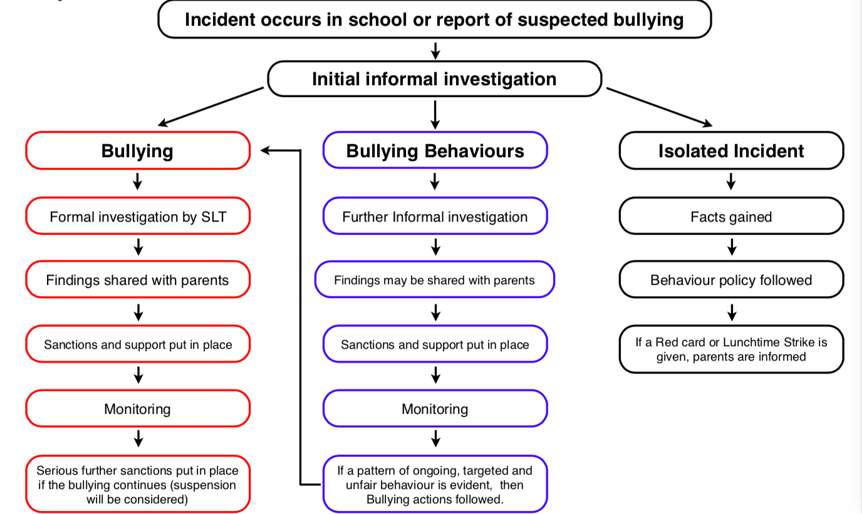

APPENDIX 1 BULLYING INCIDENT FORM
INCIDENT
Date and Time of Incident
What happened?
(what was said or done to you?)
Who was involved?
(their names or a description)
Where did the incident occur? (bus, playground, online etc.)
How did it make you feel?
Were there any witnesses? (attach witness statements)
ACTION PLAN
Describe what you would like to see done about the bullying. Think about how the situation can be stopped or prevented.
What steps can you take to make it stop?
Who can help you?
(describe what they can do)
REVIEW
Have there been any further incidents? YES / NO | Any further incidents to be recorded overleaf
If ‘NO’ | No further action (copy of the Pupil Incident Form to be put in files of al pupils concerned).
If ‘YES' | Parents to be contacted and further Action Plan to be put in place.
CONTACT WITH PARENT(S)
Name of Parent(s) Contacted
Date Parent(s) Contacted
Date of Meeting to formulate further Action Plan (Plan to be attached)
STAFF RESPONSIBILITY
Who is dealing with this incident?
RECORD OF FURTHER INCIDENTS
DATE | TIME | LOCATION
WHAT HAPPENED?
DATE | TIME | LOCATION
WHAT HAPPENED?
DATE | TIME | LOCATION
WHAT HAPPENED?
DATE | TIME | LOCATION
WHAT HAPPENED?
DATE | TIME | LOCATION
WHAT HAPPENED?
APPENDIX 2
CONTACTING PARENTS BY TELEPHONE (script)
Hello
I am telephoning as I wish to discuss an incident that occurred today involving your child.
Another pupil has reported that your child has:
physically hurt them (hit; kicked; punched etc.)
threatened them called them …….. teased them about….. made a racist comment;
and I’m afraid that this isn’t the first time that they have done this or something similar.
I have discussed this with your child following the first incident but unfortunately it has not had the impact I had hoped for and there have been further episodes of the same or similar behaviour.
Manor Park School describes behaviour that is deliberately hurtful, that is repeated over a period of time as bullying.
I think it would be really useful if home and school could work together to help Freddie understand that this isn’t acceptable behaviour and I hope you would be willing to meet with me so that we can draw up a plan to help us manage and resolve this situation.

APPENDIX 3
CONTACTING PARENTS BY LETTER
Date
Dear Mr and Mrs Smith
I have tried unsuccessfully to contact you by telephone on several occasions, so I am writing to inform you that we have had several reports of Freddie
physically hurting / threatening /making racist comments etc. another child.
I have discussed each incident with Freddie, but unfortunately it has not had the impact I had hoped for, and there have been further episodes of the same or similar behaviour.
Manor Park School describes behaviour that is deliberately hurtful, that is repeated over a period of time as bullying and therefore given the serious nature of Freddie’s recent behaviours, I think it is necessary for home and school to work together to help him understand that this isn’t acceptable behaviour.
The school take bullying very seriously and will not tolerate such behaviour. You should be aware that serious and or persistent cases of bullying can result in pupil suspension.
I would like to meet with you so that we can draw up a plan to help us manage and resolve this situation. Please can you telephone school as soon as possible and make an appointment.
Yours sincerely
Mrs Douglas
Class Teacher
APPENDIX 4

CONTACTING PARENTS BY LETTER (2)
Dear Mr and Mrs Smith
I would like to take this opportunity to thank you for attending the meeting we had on X date to discuss the bullying incidents involving Freddie reported at school.
At the meeting we recorded the following action points to help prevent any further incidents:
- Parents to discuss behaviours with Freddie highlighting that it is not acceptable to…………..
- School to monitor any further behaviours and contact parents immediately if there is any reoccurrence.
- Freddie to work in a group away from x child
- Freddie to access Elm Room at break times if required
- Freddie to attend some social behaviour sessions with Mrs Williams to discuss potential scenarios and outcomes.
I would like to invite you to a follow-up meeting on X date so that we can discuss the situation and decide if any further actions are required or if the matter has been resolved and the case closed.
Please can you contact the school to confirm that you are able to attend.
Yours sincerely
Mrs Douglas
Class Teacher

Page 11

