Manor Park Primary School

Guidelines On Keeping and Auditing Child Protection Records

Tuyet Ramzy February 2020
Review Date February 2021

POLICY AND GUIDELINES ON KEEPING AND AUDITING
CHILD PROTECTION RECORDS

Basic principles of record keeping in relation to child protection and safeguarding

Not all child protection information results in a referral – small pieces of information may not be significant on their own, but can help to contribute to a “jigsaw” picture of wider issues related to child protection. Please use the School Safeguarding Flowchart to help you decide what action to take and who to inform (Appendix 1)

RECORDS REQUIRED
Child Protection forms will be filed in purple folders and are stored in a locked cabinet in the Headteacher’s office. Access to these files is limited to the Designated Teacher.
(Please note that there is a difference between social services files and child protection files. Social services files are blue and are also kept in a lockable cabinet – these include Children With Complex Needs and Child With Additional Need (CWAN/). EHAS yellow.

Logging a concern, or reporting an incident should include the following:
  - Date of the incident
  - Date and time of the record being made
  - Name and date of birth of the child(ren) concerned
  - A factual account of what happened (include the actual words spoken by the child where possible
  - A note of any other people involved eg as witness, and what they were doing at the time of the incident
  - Action taken, and any further plans eg monitor and review
  - Printed name of the person making the record
  - Job title of the person making the record
  - Other agencies if informed
  - Signature (Print name alongside it)

GUIDELINES
- Notes may be word processed (but not saved on disc or hard disc unless absolute security can be guaranteed) or hand-written in clear hand writing
- Identify the source of the information eg “ Gemma, the holiday scheme worker, informed me the…” or “ I saw Fred on the playing field”
- Information should be factual or based on fact – record what you saw, heard etc and try to be specific (eg “Kylie was crying and rocking” rather than “Kylie was upset”)
- Opinion is okay as long as you can justify it in some way, eg “Bobby ran out of the playroom and hid in the toilets when her stepfather arrived. She appeared to be frightened”
- Make a note of the information and with whom you shared it.
- This information must then be shared with the designated teacher.

SUMMARY OF INFORMATION RECORD KEEPING AND INFORMATION SHARING PROCESS (with colour codes for forms):
Front Cover sheet: child protection concerns (lilac) | Completed by HT/DHT/SLT
Record of file access (emerald green) | Completed by person accessing file
Designated person log of auditing CP records (red) | Completed by designated teacher
Log of social services meetings attended (pale blue) | Completed by person attending meeting
Copy of interagency referral form (pink) | Completed by Designated teacher
Child protection concerns – telephone log (purple) | Completed by any person taking phone call
Logging a concern about a child’s safety and welfare (peach) | Completed by person reporting incident
Checklist for recording child protection concerns (green) | Completed by HT/DHT/SLT and person reporting concern
Note of meetings attended with parent (white) | Class teachers

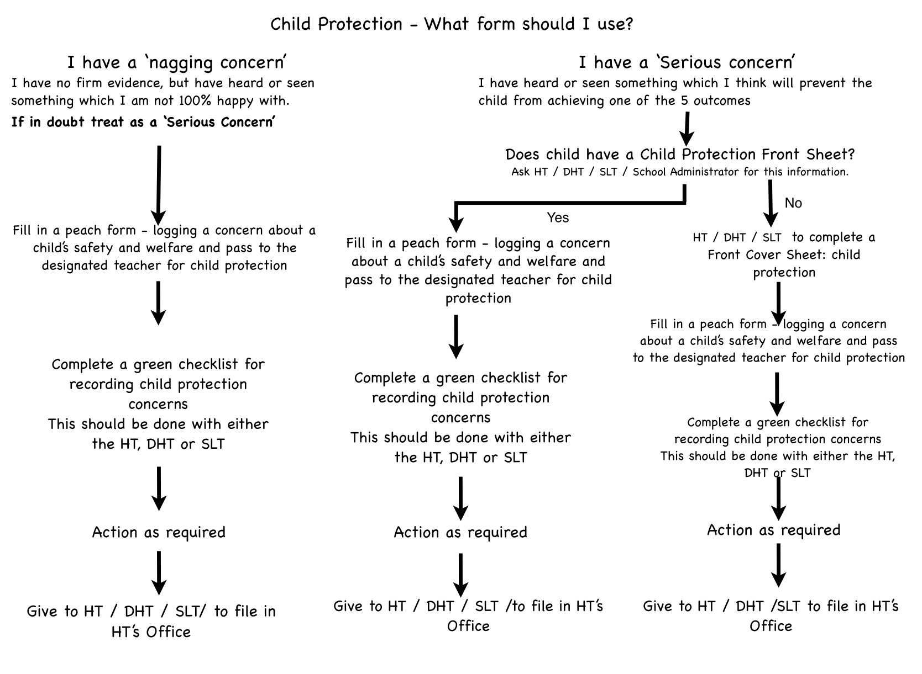

1. Information and Records

RECORDING SPECIFIC CONCERNS
Any member of staff who has a concern about a child should make a written note. This must be passed on to the designated person. (You may keep a copy for yourself provided it is kept secure and confidential). The note should be timed, dated and signed, with your name printed alongside the signature. See section 2.5 for further information.

Notes must be made as soon as possible, and certainly within 24 hours of the incident giving rise to the concern. (This is important, in case the note is needed for submission to court).

The form included here on page 5 may be helpful to reproduce for staff, but notes do not have to be officially (or beautifully!) presented: the important thing is that they are:
- factual
- using a child’s own words where possible
- a record of what you saw and heard.

Professional opinions are acceptable but only if you state the facts or observations upon which your opinion is based.

NAGGING DOUBTS
Sometimes, things that seem to be insignificant or trivial at the time, turn out to be vital pieces of information later. Much of this information may not appear to be very significant on its own, but it could contribute to a ‘jigsaw’ picture of abuse that should not be ignored. (You may also keep a copy for yourself provided it is kept secure and confidential.)

If there has been no specific incident or information, make a written note (using the Logging A Concern form). Try to identify what is really making you feel worried.

Date, time and sign the note. Print your name alongside your signature.

Pass the note to the designated person. You may keep a copy in a secure place.

Monitor the child. Record observations as factually as possible.

If several notes have been made about the child, the designated person should seek advice from the Department of Education and Children . (Director of Services for Children 693833, Head of Legal and Administrative Services 685828)

Manor Park Primary School

Logging a Concern about a Child’s Safety and Welfare

Pupil’s Name: D.O.B.
Date: |  | Time:
Your Name:  ..................................................……………  Print |  | .................................................………….  Signature
Position:
Note the reason(s) for recording the incident.

Record the following factually:  (Continue overleaf if necessary) | Who?
 | What?
 | Where?
 | When?
Offer an opinion where relevant (how and why might this have happened?)

Substantiate the opinion. Note action taken, including names of anyone to whom your information was passed and why.

Check to make sure your report is clear now - and will also be clear to a stranger reading it next year.PLEASE PASS THIS FORM TO YOUR DESIGNATED PERSON FOR CHILD PROTECTION
RECEIVED BY……………………………………………………..
DATE……………………………………….. TIME……………………………………………………………………..
ACTION TAKEN……………………………………………………………………………………………………….
PROPOSED ACTION BY THE DESIGNATED PERSON (continue overleaf if necessary)

2 Designated Person Record Keeping
The purpose of this section is to enable the designated person to ensure that all child protection information is kept in an appropriate and useful manner.

Good record keeping is essential in child protection, particularly with regard to children who are subject to a child protection plan or who are identified as vulnerable. For this reason, it is advisable to carry out a regular audit of all child protection information kept in school/ college/ Youth office, to ensure that procedures are being followed correctly.

This section seeks to answer the following questions:

- What kind of information should be recorded?
- How should notes and reports be made?
- Where should child protection information be kept?
- Who should have access to child protection information?
- How long should information be kept?
- What should happen to the information when a child leaves the school/ college/Youth Service?
- What records need to be kept when making a referral?
- What would an auditor look for in a good child protection file?

What kind of information should be recorded?

If a child protection record is started for an individual child, the record should have a front sheet in the file which records the child’s full name, date of birth, address and information about family members. (See next page for a standardised sheet that can be used). It is good practice to cross-reference files, for example, if John Smith has a sister called Jane Brown, make clear on the file what their relationship is.

If more than one file exists in relation to an individual child, then this should be recorded on each file. Each file should be dated and indicate the number of volumes e.g. January 2011, Vol. 1 of 3.

Manor Park Primary School

Front Sheet: Child Protection Record

Name of child
Any other names by which child is known, if relevant
Date of birth
Address
Other family members (include full name, relationships eg mother, stepfather etc. For U18s, include age if known
Are any other child protection files held in school/college relating to this child or another child closely connected to him/her | YES / NO
If yes, which files are relevant?
Name and Contact number of key worker (Social Care), if known
Name, address and contact number of GP, if known
Name, contact details and designation of any other agencies involved

Manor Park Primary School

Record of File Access:

Name of Pupil:

DOB:

Name | Date | Reason | Date File Returned (If taken away)

How should notes and reports be made?

At the time of making a child protection note, it is impossible to say who will eventually have access to it, or when. It may be consulted months or even years after it was written. Always bear in mind that someone who is a complete stranger to you and your establishment may need to read your record at some stage in the future. It is therefore essential that written records are accurate and clearly distinguish between fact, opinion and hearsay.

Ideally, logs of incidents should be typed. Hand written notes should be clearly legible and written in ink. All notes and reports must contain the following:
- Date of the incident
- Date and time of the record being made
- Name and date of birth of the child(ren) concerned
- A factual account of what happened, and the location where the incident took place (include the actual words spoken by the child where possible)
- A note of any other people involved e.g. as witnesses
- Action taken, and any future plans e.g. monitor and review
- Any other agencies informed?
- Printed name of the person making the record
- Job title of the person making the record
- Signature (print name alongside)

The source of the information should be identified e.g. ‘Mrs Evans a midday supervisor, informed me that….’ Or ‘I saw John in the playground at break time…’

Information should be factual or based on fact. Record what you saw, heard etc. and try not to be vague or woolly (e.g. ‘Jenny was crying and rocking’ rather than ‘Jenny was upset’).

Opinion is acceptable provided that you can give some justification for holding it (e.g. ‘Sam ran and hid under the table when his mother arrived to take him home, and clung to me when I tried to get him out. He appeared to be frightened.’)

Make a note of what you have done with the information (e.g. ‘I consulted the Headteacher, Mrs Ramzy and she said she would…’)

Try to avoid specialist jargon (e.g. ‘he is on SEN School Action Plus’), which someone from another agency would not necessarily understand.

A simplified checklist for recording information is on the next page. It might be good to include this kind of information in the staff booklet of your establishment.

Date and time of incident (DD/MM/YY and time)
Name and address of child(ren) and d.o.b.

Factual account of the incident or information, attached on separate sheet. (Who? What? Where? When?)

Opinion (substantiated), if appropriate. Add to separate sheet.
Your name (printed) and job title

Names and job titles of any other staff involved

With whom has the information been shared?
What action has been taken, and by whom?

Your signature

Date and time of log

Where is the information to be filed? Any cross-references?

Checklist for Recording Child Protection Concerns

Where should child protection information be kept?

Child protection information is confidential and should not be kept on the child’s school/college/ Youth Service file. Each establishment should have a separate, secure filing system for child protection concerns. This filing system should be easily accessible by the designated person but secure from other members of staff, for example, a locked filing cabinet in the head teacher’s office.

Each child protection file should contain all relevant reports, notes and correspondence referring to the child. Files on extended family members should be kept together and cross-referenced.

The cover of the file for the child should not indicate there is a child protection file relating to the child. Instead, where any child protection concern arises, staff should raise that concern with the designated person.

In general, information should not be removed from a child protection file, but if in exceptional circumstances information is removed then, a card should be placed indicating where the information has gone, and who has it. A record of file access form must be completed (see page 8).

Who should have access to child protection information?

Access to the information in any child protection file should be on a need-to-know basis which will be determined by the designated person on a case-by-case basis. Anyone who accesses the file should be logged on the Front Cover Sheet.

The confidentiality of the child and family should be respected as far as possible, but the welfare of the child is paramount. It would be unlikely that every member of staff needs to know the details of a case. Generally speaking, the closer the day-to-day contact with the child, the more likely the need to know an outline of the case.

Child protection files form part of a child’s “educational record” and as such the child or a parent has a right of access to that record. Access can only be denied in exceptional circumstances, for example, where there is a likely risk of significant harm. Therefore, unless there is a valid reason to withhold information, it is best practice to share all information with the child and/or parent, for example, an education report to a child protection conference should be shared with the parent(s) before the conference takes place.

Conversations between designated personnel at different education establishments are perfectly acceptable (e.g. sharing concerns or asking for information about sibling groups). Unless there is risk of significant harm, the child and/or parents should be informed before any conversation takes place. Any relevant child protection information coming to light should be carefully logged

Where there is concern that a child is at risk of significant harm, information may be shared with Social Care and/or Police and Health. In all instances the Department of Education and Children must be advised.

Child protection information should not ordinarily be shared with other persons, for example, information should not be released to solicitors, etc. If a request for such information is made, seek the advice of the Head of Legal and Administrative Services at the Department of Education and Children, 685828.

How long should information be kept?

The Department of Education and Children and Department of Social Care will keep information about the child for many years, so anything reported to Social Care and copied to Education will still be available. There is no need to keep a copy of material sent to a new school/college/Youth Service unless, at the discretion of the designated person, there are exceptional reasons for doing so.

What should happen to the information when a child leaves the school/college/ Youth Service?

If there is a current or ongoing child protection concern and the child moves establishment, then the file should be sent to the new school, college or Youth Service. The information should be sent under separate cover to the school/college file, in a sealed envelope to the Headteacher (or similar position in college or Youth Service), marked ‘Strictly Confidential’ by recorded delivery.

The advice of the Department of Education and Children should be sought with regard to the transfer of information when a child moves and there was a previous child protection concern or other information such as “nagging doubts” had been recorded.

If a child leaves the school/college and you have not been informed where the child’s new school/ college will be, monitor this carefully. If the child is subject to a child protection plan, inform the key worker. If the child is not subject to a plan but there are current child protection concerns, contact the duty social worker.

Even where there are no child protection concerns, if there is no request for the school/college file within 21 days, inform the Head of Legal and Administrative Services at Hamilton House, 685828.

If the file is not transferred to a new school or college then the file should be retained at the establishment until the year of the child’s 25th birthday.

What records need to be kept when making a referral?

Where possible, prior to making a referral to Social Care, you should discuss your concerns with either the Director of Services for Children 693833 or the Head of Legal and Administrative Services 685828.

If a referral is made to Social Care, the school/college should keep a written note of all actions taken together with a copy of the completed interagency referral form and all other information passed. Copies should also be sent to the Department of Education and Children.

Auditing Child Protection files kept by the school/college

The designated person should, as good practice, carry out an occasional audit of the child protection files to ensure that adequate records are being kept in an appropriate manner. The Department of Education and Children may be able to assist with this task if requested.

The check should cover the following:

  - Cover sheet with name, address, d.o.b., family members and name, address and contact number of Social Care (if the child is subject to a child protection plan, this should be the key worker).
  - Note on child’s regular school/ college file.
  - File cross-referenced with other family members, if appropriate.
  - Cross reference to additional files, if appropriate.
  - Records and notes typed or written in legible handwriting.
  - Incident date (including year!), time, place.
  - Name, address and d.o.b. of child(ren) concerned recorded on each sheet.
  - Factual outline of incident /concern/allegation/disclosure.
  - Opinion substantiated, if given.
  - Clear names, job titles of staff involved.
  - Signature, printed name, job title of person making record.
  - Note of action taken, and with whom information was shared.
  - Note of copy sent to Social Care and to the Department of Education and Children, as appropriate.

AUDIT OF CHILD PROTECTION FILES KEPT BY SCHOOL

(TO BE COMPLETED BY HT/DHT/SLT)

PUPIL Date of Birth:__/__/__

Date of Audit

File has front cover sheet with all parts completed

File has been cross referenced with other family members

Records and notes are typed or written in legible handwriting

Incidents have date, time and place

Factual outlines of incident/concern/allegation/

disclosure

Opinion is substantiated

Clear names, job titles of staff involved

Signature, printed name, job title of person making record

Note of action taken, and with whom information was shared

Note of copy sent to Social Care and to the Department of Education and Children, as appropriate

Manor Park Primary School -FRONT OF FILE RECORD
LOG OF SOCIAL SERVICES MEETINGS HELD REGARDING -

PUPIL:
DATE OF BIRTH:

NB: regarding security around transporting confidential notes from out of school when meeting are held off site.

DATE OF MEETING | PURPOSE OF MEETING | TIME AND PLACE OF MEETING | PERSON WHO ATTENDED FROM SCHOOL | DATE,TIME AND PLACE OF NEXT MEETING | MINUTES OF MEETINGS TAKEN BY | MINUTES OF MEETING RECEIVED

Child Protection Concerns – Telephone Record
Date and time of phone call (DD/MM/YY and time)
Phone call from
Your name (printed) and job title
Name(s) of child(ren) and d.o.b.

Factual account of the information given.
(Who? What? Where? When?)

Opinion (substantiated), if appropriate.
With whom has the information been shared?
What action has been taken, and by whom?
What advice have you given?

Your signature
Date and time of log
Where is the information to be filed?
Any cross-references?

MEETINGS WITH PARENTS

PUPIL:

Date:

Present:

Points discussed (bullet points):

Actions to be taken:

Signed: (all present at meeting)

“Educational Record” is defined in the Data Protection Act 2002

